
Multiple Choice Exam term 4 – 2015 Name:__________________
Year 9 Mark /60
Circle the correct answer. Formula sheet (1 A4 sheet double sided) and calculators may be used for this part.

1 Find the size of angle b if a = 67°.
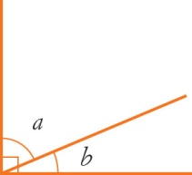
A 23° B 45°
C 67° D 77°
2 Find the size of angle b if a = 34°.

A 34° B 124°
C 56° D 146°
3 Find the size of angle d if a = 102°, b = 66° and c = 70°.
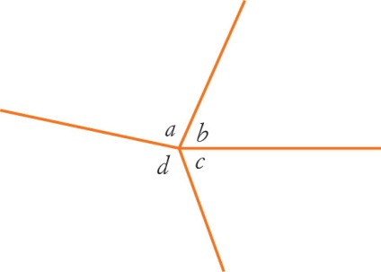
A 102° B 122°
C 117° D 135°
4 What can be said about supplementary angles?
A They are equal.
B They add up to 90°.
C They add up to 180°.
D They add up to 360°.
5 What can be said about vertically opposite angles?
A They are equal.
B They add up to 90°.
C They add up to 180°.
D They add up to 360°.
6 What angle is complementary to 30°?
A 30° B 60°
C 90° D 150°
7 Which statement is true about this diagram?
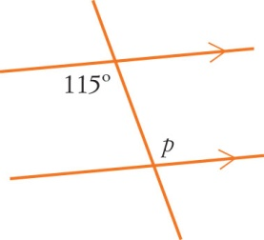
A p = 65 (alternate angles)
B p = 65 (co-interior angles)
C p = 115 (alternate angles)
D p = 115 (co-interior angles)
8 Find x.
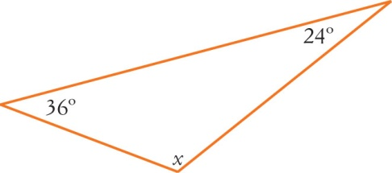
A x = 36° B x = 60°
C x = 120° D x = 150°

9 Find x.
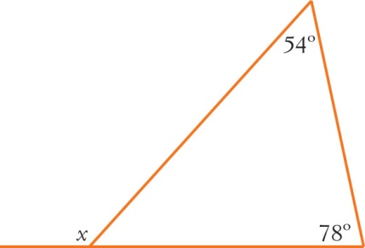
A x = 48° B x = 62°
C x = 102° D x = 132°

10 An isosceles triangle has an angle size of 70°. Its other two angles could be:
A 55°, 55° B 70°, 50°
C 40°, 40° D 50°, 60°
11 Which equation best describes the relationship between the four angles a, b, c and d?
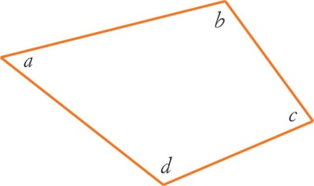
A a + b + c + d = 360°
B a + b + c + d = 180°
C a + c = b + d
D d = a + b + c
12 Find x.
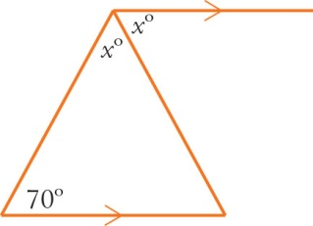
A x = 35° B x = 55°
C x = 70° D x = 110°
13 Find e.
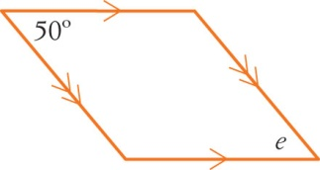
A 40° B 50°
C 60° D 130°
14 The pair of lines in the following diagram are:

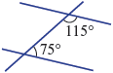

A parallel, since cointerior angles are supplementary
B parallel, since alternate angles are supplementary
C parallel, since corresponding angles are supplementary
D not parallel, since cointerior angles are not supplementary
E not parallel, since alternate angles are not supplementary

15 The value of x in the following diagram is:
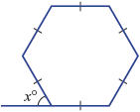

A 30° B 36° C 45°

D 60° E 120°

16 Which of the following sides is the hypotenuse of this triangle?
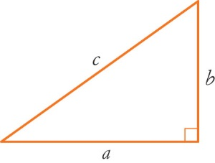
A a B b
C c D a or b
17 Which angle is opposite the hypotenuse in a
right-angled triangle?
A The complementary angle
B The acute angle
C The smallest angle
D The right angle
18 Find x
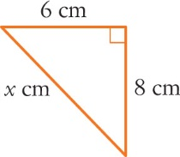
A x = B x = 10
C x = 12 D x = 14

19 Find the value of r?
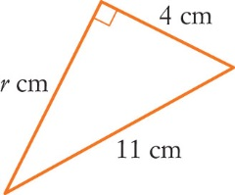
A r ≈ 11.7 B r ≈ 10.25
C r = 8 D r ≈ 6.25
20 Which side of the triangle is the opposite?
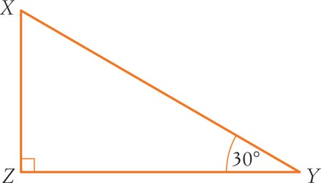
A XZ B XY
C YX D ZY
21 Which side of the triangle is the adjacent?
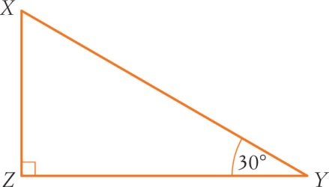
A XZ B XY
C YX D ZY

Questions 22 and 23 refer to the following diagram:

22 For the given triangle:
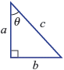

A B C

D E

23 For the given triangle:

A B C

D E

24 What is the size of ∠ θ if QR = 12 m and PQ = 37 m? Round your answer to the nearest degree.

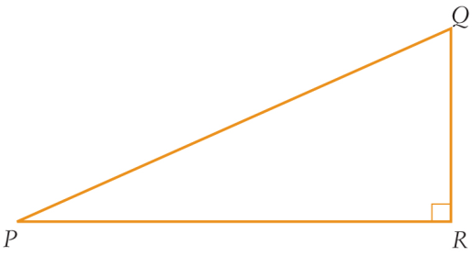
θ
37m
12m
A | 72 | C | 70
B | 71 | D | 19

25 What is the size of ∠θ if PR = 36 m and PQ = 45 m? Round your answer to the nearest degree.
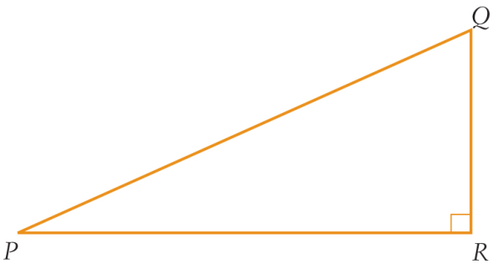
θ
45m
36m
A | 37 | C | 53
B | 36 | D | 54
26 What is the length of x if ∠P = 22 and PQ = 56 cm? Round your answer to the nearest whole number.

x
56cm
22º
A | 35 cm | C | 26 cm
B | 18 cm | D | 21 cm

27 What is the length of y if ∠P = 18 and PQ = 7.6 km? Round your answer to one decimal place.

7.6km
18º
y
A | 8 km | C | 7.2 km
B | 6.9 km | D | 7.7 km

28 What is the length of x if ∠P = 10 and PR = 150 cm? Round your answer to the nearest whole number.


150cm
10º
x
A | 40 cm | C | 26 cm
B | 24 cm | D | 44 cm

29 What is the length of y if ∠P = 36 and QR = 66 mm? Round your answer to the nearest whole number.


66mm
36º
y
A | 82 mm | C | 112 mm
B | 53 mm | D | 39 mm

30 What is the length of x if ∠P = 16 and QR = 49 km? Round your answer to the nearest whole number.


49km
16º
x
A | 178 km | C | 171 km
B | 13 km | D | 14 km

